Cars and Driving – Part 1
Quote: Have you ever noticed that anybody driving slower than you is an idiot, and anyone going faster than you is a maniac? – George Carlin, American Comedian
Know Your Car 1
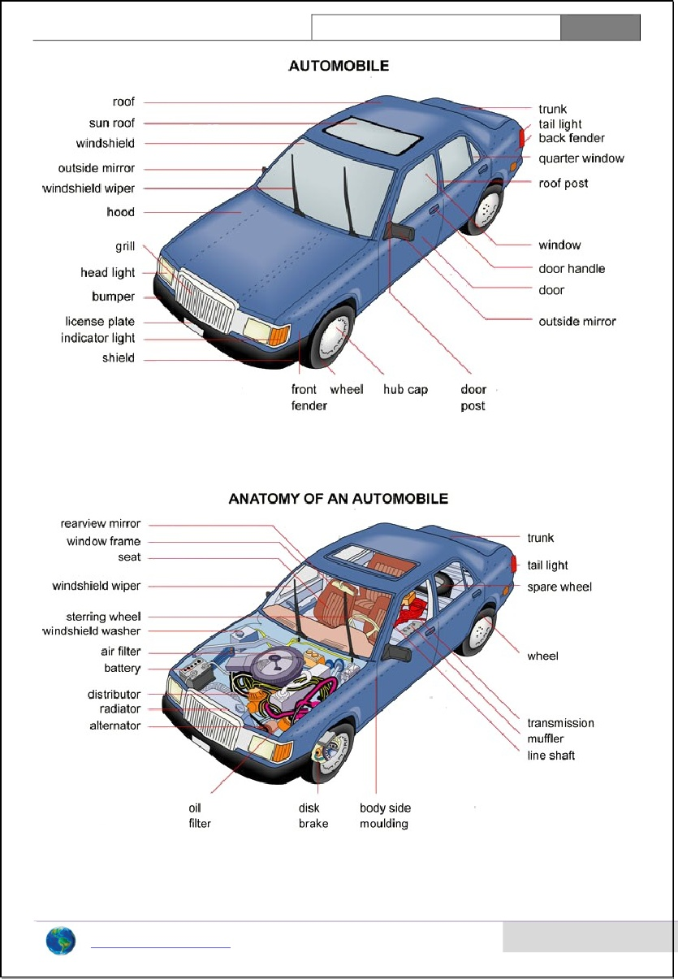
How well do you know the parts of a car? Use the list on the right to identify the parts shown in the picture. Some names are different in British English; do you know them?
1. trunk 11. windshield
2. fender 12. license plate
3. wheel 13. side mirror
4. door 14. quarter window
5. window 15. roof post
6. sunroof 16. taillight
7. tire/ tyre 17. windshield wiper
8. hood 18. door handle
9. grille 19. turn signal
10. bumper 20. headlight

Out for a drive with the guys
I had only had my license for six months, and my buddies and I were out joyriding one Friday night in my dad’s car. It was sort of a land-boat, but at least it wasn’t a station wagon. First we decided to set a new speed record on the interstate. That part of the highway didn’t have much traffic, so there wasn’t much chance of a speed trap. When there were no other cars around us, I floored it, and we were barreling down the road at more than 100. I pinned the speedo at 120 – a new record!
Suddenly I saw the blue flashers up ahead, and I thought I was toast. I slammed the brakes and got us down to a respectable 65, then I slowed it down to 45 as we passed the cop cars. There were three of them at the scene of an accident. There was only one damaged car, but it rolled over and was totaled. I don’t know what happened. Maybe the guy had been drinking, or maybe it was a hit-and-run and the other guy got away. Either way, it made me decide to be a little more careful.
We decided to go into Springfield for some fun. On the way into town, some moron was tailgating me, so I tapped the brakes a couple of times to make him back off. I looked in the rearview and could see him cursing at me, but I laughed. Finally he decided to pass, and I figured it was better to let him go. He tried to yell something as he went by, but we all gave him the finger. It was a riot.
We were cruising around looking for a hotspot we had heard about where a lot of people hang out, but I wasn’t sure where it was. So I pulled over to ask someone for directions. A hot girl told us that we had to turn around and head back the other way for a mile. Then she said we should hang a right at McDonalds, and the place would be about a half mile up on the left. When I pulled back into traffic, some geezer in an old beater almost sideswiped me. That would have been a bitch to explain to my dad. We found the place and pulled into the parking lot. I decided to back into a parking space so that it would be easier to pull out later. We locked it up and went inside.
Discussion 1:
- How old do you think the author might be? Is he a good driver? Why / why not?
- How old were you when you first drove a car? Were you ready to drive on your own?
- Do you think you are a good driver (or would you be)? Why or why not?
- What do you think of the drivers in your city or region?
- What does this quote mean: Never drive faster than your guardian angel can fly.
Language
Match the terms on the left with the definitions on the right.
- backseat driver a. to suddenly pull in front of another car, often dangerously
- rush hour b. time of day when there is a lot of traffic in the city
- get a flat c. turning in a half circle to go the other way on a street
- U-turn d. a passenger who constantly tells you how to drive
- 3-point turn e. to move the car in reverse
- fill up f. uses for fuel
- cut (someone) off g. to hit an object (or person or animal) with the car’s wheels
- back up h. when you lose all the air from your tire
- run over i. to put as much fuel as possible in the car’s tank
- runs on h. turning the car 180 degrees

Now use the terms to complete sentence:
- I hate it when some idiot _______ me ______ in traffic.
- I would have been here sooner, but I _________________ and had to fix it.
- This street is wide enough; make a ______________ here and go back the other way.
- We’re low on gas. We’d better find a station and ______________ before we run out.
- “Why do they call it ____________________ when nothing moves?” – Mork from Ork
- I don’t like driving in the country because I’m afraid I might ___________ an animal.
- This street is too narrow for a U-turn; you’ll have to make a ____________________.
- I hate driving with your mother in the car; she’s such a _______________________.
- My new car ___________________ diesel instead of gasoline.
- You pulled up too far in the space. You should __________________ about a meter.
Discussion 2:
- What are the advantages of owning a car? The disadvantages?
- What kinds of cars do you like the best? Why?
- How long did it take you to learn to drive? Who taught you?
- What do you know about car repair / maintenance? How much can you do yourself?
- What is the longest trip you have taken by car?
- Do you like to drive at night? Why or why not?
- Have you ever been in a car accident? What happened?
- Have you ever been stopped by the police? Why? What happened?
Know Your Car 2
Now let’s look at some other parts of the car? Use the list on the right to match to the picture. Some names are different in British English; do you know them?
1. muffler 10. drive train
2. seat 11. transmission
3. wheel 12. rearview mirror
4. air filter 13. spare tire
5. alternator 14. steering wheel
6. battery 15. distributor
7. radiator 16. windshield washer fluid
8. disk brake 17. window frame
9. oil filter 18. body side molding

